**const** **int** **TP** **=7;** **const** **int** **echop** **=** **8;**

unsigned int max_d =23300; void setup(){

pinMode(TP,OUTPUT); digitalWrite(TP,LOW); pinMode(echop,INPUT);

Serial.begin(9600);

**}**

void loop(){ unsigned long t1; unsigned long t2; unsigned long pw; float cm;

float inches;

digitalWrite(TP,HIGH); delayMicroseconds(10); digitalWrite(TP,LOW); while(digitalRead(echop)==0); t1 =micros();

while (digitalRead(echop)==1); t2=micros();

pw=t2-t1; cm=pw/58; inches=pw/148.0;

if(pw>max_d)

**{**

Serial.println("Out of range");

**}**

else

**{**

Serial.println("****"); Serial.print("The distance is"); Serial.println(cm);

if(cm<100){

}Serial.print("****");

**}**

delay(1000);

**}**





g wokwi.com/projects/347301236132807252

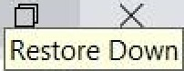

Restore Down

New Tab Creating Servlet in...

/manager Email Sending in Se... S Microprocessors an... Java NPTEL Week-2... S Problem solving thr... S Problem solving thr... Find the sum of tw... Program to reverse... »

|  |  |  |  |  |  |  |  |
| --- | --- | --- | --- | --- | --- | --- | --- |
| WOKWi | - | SHAPE |  | s ketch.ino | y‘ | Docs | _ |
| sketch.ino | diagram.json | Library Manager | ” |  |  |  |  |

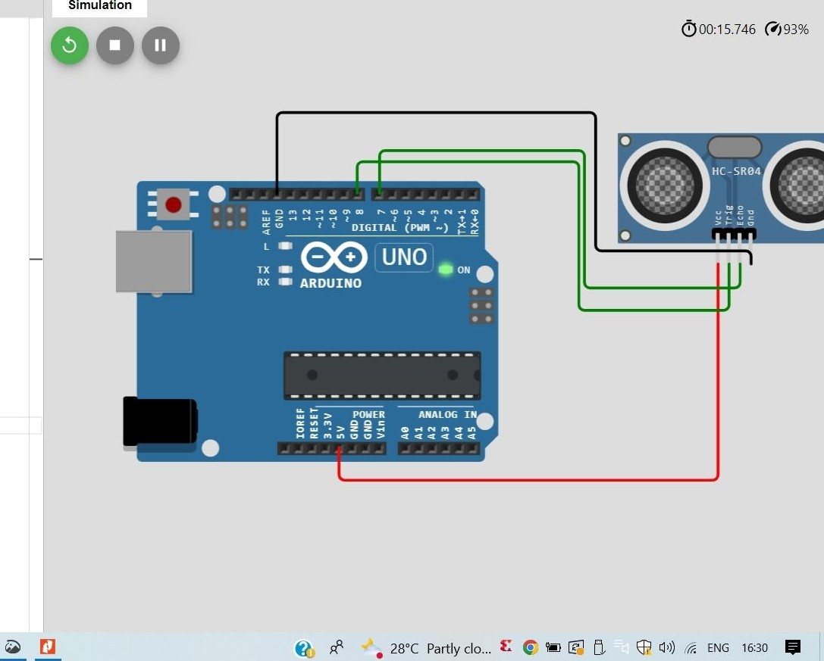11 Serial.begin(9600);

12 }

1. void loop(){
2. unsigned long tl;
3. unsigned long t2;
4. unsigned long pw;

lB float cm;

19 float inches;

1. digitalNrite(TP,HIGH);
2. de1ayMicroseconds(10);
3. digitalNrite(TP,LOW);

Z4 while(digitalRead(echop)==0);

?5 t1 =micro();

Z7 while (digitalRead(echop)==1);

ZB tZ=micros();

29 pw=t2-tl;

30 Cm=pw/58j

31 inches=pw/148.6j

32

33 If(pw›oax d)

34 (

35 Serial.println(”Out of range”);

36 }

37 else

3B (

39 Serial.println("****”);

*4* Serial. print (”The distance is) ;

41 Serial. println(cm) j

4Z

43 if(cm‹100{

}Serial.print(””**);

